**A Project Report on**

**RESUME(PROFILE)**

**USING HTML & CSS**

submitted by

**R. Sai Poornima - GQT-S0152**

under the mentorship of

**KESHAVA MURTHY**



**GLOBAL QUEST TECHNOLOGIES**

[info@gqtech.in](mailto:info@gqtech.in)

Yelahanka Satellite Town,

Bangalore, Karnataka - 560064.

[2023]

**Signature of the mentor Signature**

**Keshav Murthy G.R.Narendra Reddy**

**INTRODUCTION**

**HISTORY OF HTML:**

**HTML** stands for **Hyper Text Markup Language**.

* It is used to share the information over the internet.
* HTML id developed by Tim Berner’s Lee in 1991.But officially in 1993.
* The First version of HTML consists of “18 tags”
* HTML follows certain rules and regulations setup by “**ISO**”.
* International Organization for standardization is set of rules and regulation are present in ‘**SGML**’ document.

**Versions of HTML**

* **HTML-1** version in the year 1993.
* **Html-2** version in the year 1995.
* **HTML-3.02** version in the year 1997.
* **HTML-4.1** version in the year 1999.
* **HTML-5** version in the year 2014.

**Features of HTML**

* It is easy to Learn.
* It is a tag based language.
* HTML is supported by multiple browsers.
* First web browser is Netscape navigation which was developed by the “Mosiac”.
* It is a portable language.
* **WORA** stands for ‘write once run anywhere’

**Limitation of HTML**

* HTML has less designing capabilities.
* It is dependent on other technology such as CSS in order to develop well designed Webpages.
* HTML has no programming capabilities.
* Using HTML and CSS we can develop only static Web page.
* In order to write the HTML code required an editor such as VS Code, Notepad, Eclipse.
* In order to execute the HTML code we required Web browsers.Like Chrome, Firefox, edge, Opera Safari .

**CSS**

* **CSS** stands for **Cascading Style Sheets**.
* It was developed by W3C to add stylings to the HTML elements.
* W3C stands for World Wide Web.com

**Versions of CSS:**

* CSS-1 (level-1) in the year 1996.
* CSS-2 (level-2) in the year 1998.
* CSS-3 (level-3) in the year 1999.

**Why do we required CSS ?**

* Since HTML has less designing capabilities we cannot create well designed or most appealing Websites.
* Using HTML we cannot add style, animation and transitions to the Webpage.
* Therefore we require CSS to create well designed Webpages.

**Advantages of CSS**

* It allows to add styles, animation and variouses effects to the Webpage.
* It allows us to develop the Webpage rapidly. It is also know as RAD ( rapid application Developer).
* It allows us to separate from formatting develop page to the presentation of Webpage.
* It allows to create well designed Websites.

**Limitations of CSS**

* Using CSS we can perform static styles for the Webpages.
* In order to create dynamic styling for the Websites. We must make use of scripting language such as JavaScript and Libraries of JavaScript.

**Types of CSS:**

1. Inline CSS
2. Internal CSS
3. External CSS
4. Default Browser CSS

**Inline CSS:**

Defining all the CSS properties within the style attribute inside the opening of the tag is referred to as Inline CSS.

**Internal CSS:**

Defining all the CSS properties within <style> inside the HTML document is referred to as Internal CSS.

**External CSS:**

Defining all the CSS properties within as external Script or File with an extension CSS is referred to as External CSS.

* In order to link external CSS file within the HTML document we must use of <link>.
* The value for the ‘ref’ attribute should be ‘stylesheet’.

**RESUME(PROFILE)**

**Scope of the document**

I was created Resume using HTML & CSS.The Scope of the document is:

**Personal Information:** It includes my name, contact information, and a professional summary or objective statement.

**Education:**I have Listed my educational background, including institutions attended, degrees earned, and relevant dates.

**Skills:** I have mentioned technical and soft skills in a clear and organized manner.

**Projects:** I have done two projects in my college, that is also mentioned in this resume.

**Achievements and Awards:** I have completed some courses in online platform i.e Hackerrank.

**Certifications:** I achieved few cirtificates during my college and internships thoes are mentioned in this resume.

**Design and Styling:** Implemented my resume using HTML and CSS skills to design a visually appealing and well-structured resume.

**Technologies Used**

* HTML5
* CSS3

**Our Project**

**Root Structure:**

**RESUME**

→**CODES**

→**HTML_Files**

→Resume1.html

→**CSS_Files**

→Resume1.css

**PROJECT REPORT**

→FRONT END PROJECT 1 RESUME.DOC

**SCREENSHOTS**

→ALL THE CORRESPONDING SCREENSHOTS OF PAGES.

**Source Code:-**

**Resume.html:**

<!DOCTYPE html>

<html lang="en">

<head>

<meta charset="UTF-8">

<meta name="viewport" content="width=device-width, initial-scale=1.0">

<title>Document</title>

<link rel="stylesheet" href="resume1.css">

</head>

<body>

<div id="id" >

<div id="id1"> <div id="id2" style="padding:10px">

<img src='saiprofile.jpeg' alt="" height="250px" width="250px" style="border-radius:50%;padding:20px">

</div>

<div id="id5" style="width:80%;height:17%;margin-left: 8%;margin-top: 4%;">

<h2 class="h2"style="">Contact</h2>

<h3 class="class2">+91 9346524606</h3>

<h3 class="class2">rachamallasaipoornima@gmail.com</h3>

<h3 class="class2">kadaraguttapalli(v),peddavaduguru(m),<br>Anantapur(d),Andhrapradesh,515455</h3>

<a class="class2" style="color:white"href="http://in/linkedin.com/in/sai-poornima-r">in/linkedin.com/in/sai-poornimar</a><br><br>

<a class="class2"style="color:white"href="http://github.com/saiRachamalla">github.com/saiRachamalla</a> <br>

<br>

</div>

<div id="id7" >

<h2 class="h2">Achievements</h2>

<ul><li>PYTHON- HackerRank: "⭐⭐⭐⭐⭐"</li>

<li>JAVA - HackerRank: "⭐⭐⭐⭐⭐"</li>

<li>SQL-HackerRank:"⭐⭐⭐"</li>

<li>CodeChef Stars: "⭐⭐"</li>

</ul>

</div>

<div id="id7" style="margin-top: 4%;">

<h2 class="h2"style="margin-top: -15%;">Skills</h2>

<ul><li>CORE JAVA</li>

<li>PYTHON</li>

<li>HTML5,CSS3,JAVASCRIPT</li>

<li>MYSQL</li>

<li>MANUAL TESTING</li>

</ul>

</div>

<div id="id7"style="margin-top: 2%;">

<h2 class="h2">Interests</h2>

<ul>

<li>Web development</li>

<li>Software development</li>

<li>Data Science</li>

</ul>

</div>

<div id="id7" style="margin-top:-20%;">

<h2 class="h2">Strengths</h2>

<ul>

<li>Quick Learner</li>

<li>Adapatability and flexibility</li>

<li>Teamwork and collaboration</li>

</ul>

</div>

<div id="id7" style="margin-top:-20%;">

<h2 class="h2">Languages</h2>

<ul>

<li>English</li>

<li>Telugu</li>

<li>Hindi</li><li>Kannada</li>

</ul>

</div>

</div>

</div>

<div id="id4">

<div style="border:1px solid orange;height:170px;width:190%;background-color: orange; margin-top: -20px;">

<h1 style="font-family: sans-serif;padding-left:20px;">RACHAMALLA SAI POORNIMA</h1>

<p style="font-family: sans-serif;color:black;font-stretch: ultra-expanded;text-align: left;margin-left: 22px;">

<b>FULLSTACK DEVELOPER</b></p>

</div>

<div id="id6">

<h2 style="color:black;font-family: sans-serif;">About Me</h2>

<p style="padding:-1%">Looking forward to work in an organization that offers challenging

assignments and competitive work atmosphere leading to a professional growth with a dynamic

and progressive organization where my skills, talent and abilities will be utilized to fullest

while being resourceful innovative and flexible.</p>

</div>

<div class="ed" style="width:190%;margin-left: 2px;">

<h2 class="ed1" style="margin-left: 0px;padding-left: 2%;font-size:25px">Certifications</h2></div>

<div class="ed2" style="margin-top: 10px;width:800px">

<ul>

<p id="p2">1.MTA Introduction to programming using java-certified 2022 was issued by Microsoft.</p>

<p id="p2">2.Certificate of Python for beginners by HackerRank.</p>

<p id="p2">3.Pursiung Java Fullstack and Python Fullstack development.</p>

</ul>

<br>

<div class="ed"style="width:126%">

<h2 class="ed1">Projects</h2></div>

<div class="ed2">

<h4 id="year">E-Waste Management : </h4>

<p id="year" style="width:80%;margin-left: 12px;">Website where the users and municipality corporators

can login,users can upload photos and share location of wastage to collect by municipality workers.</p>

<p id="degree" style="width:80%;margin-left: 12px">Techstack: HTML,CSS,JAVASCRIPT,MYSQL</p></div>

<div class="edu">

<div class="ed2">

<h4 id="year">Movie Recommendation System : </h4>

<p id="year" style="width:80%;margin-left: 12px">Web application recommends movies to

the users based on previous activities of the user by using machine learning algorithms.</p>

<p id="degree" style="width:80%;margin-left: 12px">Techstack:Python,HTML,CSS,JAVASCRIPT</p>

</div>

<br>

<div class="edu"style="width:126%">

<div class="ed"> <h2 class="ed1">Internship</h2>

</div>

<div class="ed2" style="margin-top: 10px;width:80%">

<h4 id="year">PANTECH SOLUTIONS</h4>

<p id="p1" style="text-decoration: underline;margin-left:-4px;">Data Analytics : </p>

<p id="p1" style="margin-left:-4px;">The virtual internship for 30 days in which have

learnt creating Dashboards & Charts using Tableau and PowerBI tools and python modules

includes Numpy,Pandas,Matplotlib and basic Machine Learning algorithms </p>

<br><h4 id="year">GLOBAL QUEST TECHNOLOGIES</h4>

<p id="p1" style="margin-left:-4px;">The Full Stack Development internship at Global Quest

provides practical training by industry experts. Learn both front-end and back-end skills

for a comprehensive understanding of web development. Elevates capabilities with real-world

projects and guidance from experienced professionals </p>

</div>

</div>

<div class="ed" style="margin-top: 26%;width:126%">

<h2 class="ed1" >Education</h2></div>

<div class="ed2">

<h4 id="year" >2023</h4>

<p id="year">Jawaharlal Nehru Technological University, Anantapur - CGPA &nbsp;8.5</p>

<h4 id="degree">Bachelor Of Technology in CSE </h4></div>

<div class="edu">

<div class="ed2">

<h4 id="year" style="margin-top: -1%;">2020</h4>

<p id="year">Sri Venkateswara Govt , Polytechnic - 92 Percentage</p>

<h4 id="degree">Diploma in CSE</h4></div>

</body>

</html>

**resume.css:**

*{

font-family: sans-serif;

box-sizing: border-box;

}

#id{

margin-left:12%;

width:75%;

border-radius: 7px 7px 7px 7px;

background-color: rgb(215, 234, 250);

}

#id1{

height:1700px;

width:30%;

background-color: rgb(48, 43, 43);

border-radius: 7px 0px 0px 0px;

margin-top:-1%;

}

#id2{

height:16%;

width:60%;

margin-left: 8%;

border-radius:50%;

background-size: cover;

margin-top: 1;

}

#id4{

width:550px;

height:200px;

margin-left: 34%;

margin-top: -1700px;

padding-left:20px;

}

#id7{

width:80%;height:15%;margin-left:10%;margin-top: 1%;

font-size: 17px;

}

li{ color:aliceblue;

padding:5px;

list-style-position: outside;

}

.h2{

font-size: x-large;color:rgb(21, 23, 25);font-family: sans-serif;

color:orange;min-height:40px;line-height:40px;

margin-top: 10px;text-align: justify;width:200px;padding-left: 20px;

}

h1{

font-size: 50px;

font-stretch:ultra-expanded;

color:black;

width: 800px;

font-weight: 700;

}

.class1{

color:aliceblue;

font-family: sans-serif;

font-size:larger;

margin-top: 1%;

}

.class2{

color:aliceblue;

font-family: sans-serif;

font-size: medium;

margin-left: 9%;

}

#id6 {

color:black;

padding:3%;width:170%;

font-size: larger;

}

.ed{

height:40px;background-color: rgb(48, 43, 43);

}

.ed1{

color:orange;

min-height: 50px;

line-height: 40px;

margin-top:-10px;

padding-left: 20px;

}

.ed2{

width:110%;height:135px;border:0px solid white;margin-top:10px;font-size: large;

}

#year,#degree{

color:rgb(27, 155, 224);margin-top: 5px;padding-left:20px;color:black

}

#p2{

color:black;margin-left:-2.5%;

}

#p1{

padding-left: 5%;

color:black

}

#smalldiv1{

height:100px;

border:2px solid black;

width:40px

**Output:**

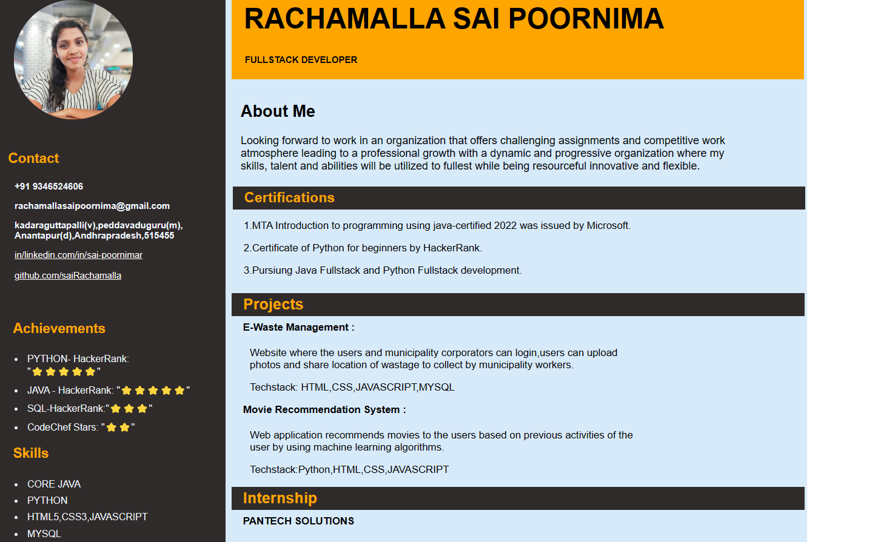

Fig:1.1

Fig:1.2

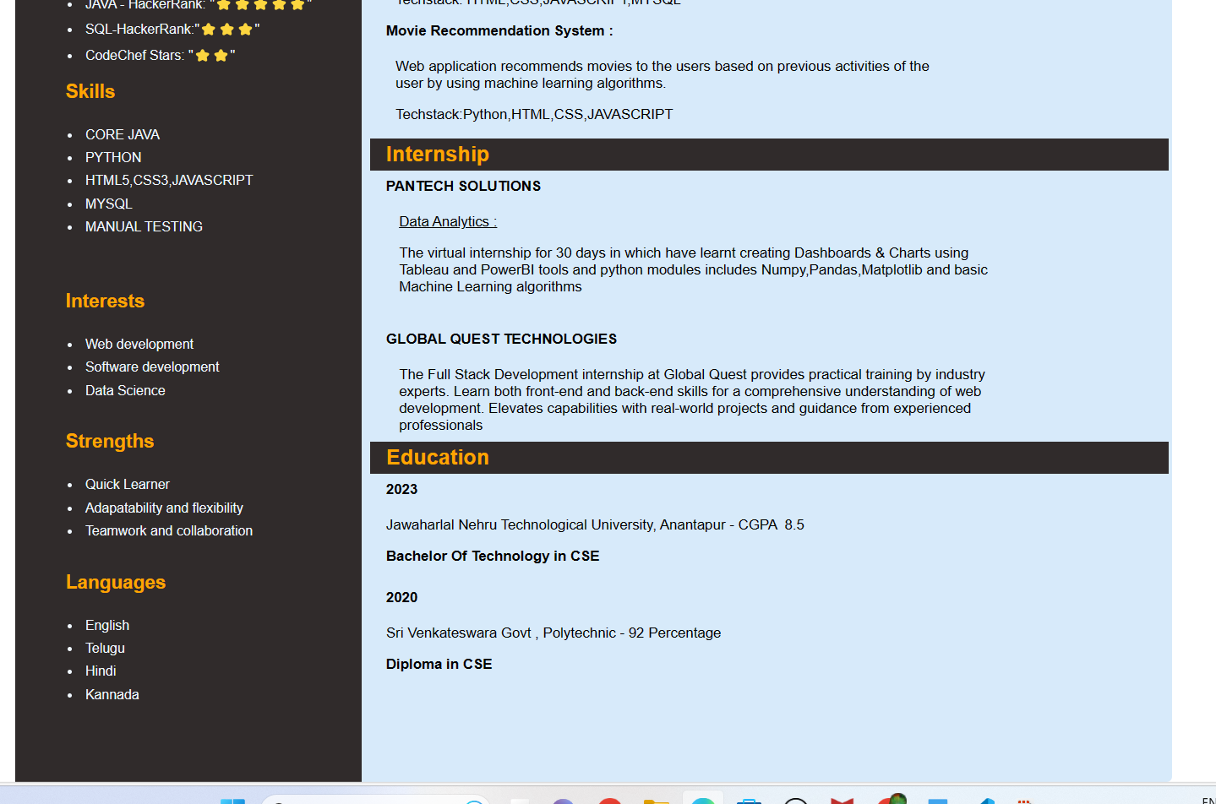

Fig:1.3

**Conclusion**

"In crafting this resume using HTML and CSS, I aimed to create a professional and visually engaging representation of my qualifications and experiences. With a strong educational background, a proven track record in [Computer science and Engineering], and a diverse skill set that includes [Java fullstack Development, HTML,CSS,Java Script,MySql].

This resume serves as a snapshot of my journey and abilities, and I am ready to provide more detailed information and discuss how I can add value to your organization.